Work Related Travel and Expense Claims | Section: Financial Processes  Number: 1.0
Approved: | Page: 1 of 3
Revised: | Scope: All Employees, students and volunteers

POLICY:

Community Living Oakville (CLO) will reimburse employees, students and volunteers for approved work related expenses.

PROCEDURE:

CLO will reimburse the following approved work related expenses:

Mileage

The Employer shall reimburse the employee forty eight (48) cents per kilometer when the Employee is requested to use their vehicle on behalf of the Employer.

Parking

The Employer will reimburse the employee for necessary parking meter expenses incurred while on authorized CLO business. Where possible, the employee will obtain a parking receipt and submit same to the Community Living Oakville office for reimbursement.

Meals

Pre-approved meal expenses shall be reimbursed upon the submission of receipts to a maximum allowed as follows:

Breakfast - $9.00
Lunch - $13.00
Dinner - $22.00

An employee shall be permitted to combine the amounts for each pre-approved meal expense for so long as the total amount does not exceed the prescribed allowable limit.

Vehicle Insurance

The Employer agrees, for those employees required to carry the people we support as passengers in their personal automobile on Employer's business, to reimburse the employee for the cost of that portion of insurance premium that covers an endorsement to carry passengers.

For that purpose, the Employer agrees, upon written request, accompanied by receipt of proof of purchase to reimburse the employee up to one hundred and seventy-five dollars ($175.00) per calendar year.

Damage to Vehicles

It is understood that the use of personal vehicles to transport people we support may occur. This can lead to the vehicle interiors having been soiled, broken or ripped by the actions of the people we support. Damage to exterior of vehicles may also occur. The employee may submit a request for cleaning or repair and, the employer will not unreasonably deny these requests. It is understood that the employer will not reimburse for exterior car detailing or washes.

Clothing Reimbursement

Each situation of damage to staff's personal property by people receiving service will be reviewed by the manager/director of CLO. Clothing damaged through no fault of the employee in the course of the employee's duties shall be repaired, cleaned or replaced by the employer upon damaged clothing being produced up to a maximum of fifty dollars ($50) per article/item.

CLO will not reimburse the cost to repair/replace valuables damaged in the course of an employee's duties. Glasses will continue to be repaired/replaced.

Employees who are required to accompany people we support in a pool on a weekly basis over a six (6) month period or more, upon submitting a receipt, will be reimbursed up to fifty dollars ($50.00) per year for a swim suit.

Submitting Expense Claims

Expense claims should be submitted on the Expense Claim form monthly but must be submitted for reimbursement within three months of the expense being incurred. All expenses up to March 31st of each year must be submitted by April 7th of each year.

Deliberate falsification of an expense claim will result in disciplinary action up to and including dismissal.

Approved by:

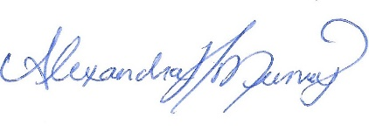 April 11, 2022
_______________________ ______________________
Executive Director Date

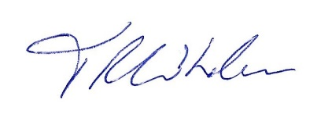 April 11, 2022
_______________________ ______________________
Board President Date

