Perquisites | Section: Procurement  Number: 0.2
Approved: April 11, 2022 | Page: 1 of 2
Revised: | Scope: All Employees

POLICY:

Community Living Oakville’s Perquisites Policy is in accordance with, and governed by, the Broader Public Sector Perquisites Directive issued by the Management Board of Cabinet effective August 2, 2011.

A perquisite is not allowable if it is not a business related requirement for the effective performance of an employee’s job. Insured benefits are not considered to be perquisites.

Any perquisite provided outside of the insured employee benefits package for staff must be approved by the Executive Director. Any perquisite provided outside of the insured employee benefits package for the Executive Director must be approved by the Board of Directors.

A summary of perquisites provided by Community Living Oakville, if any, will be made publicly available on an annual basis.

The following perquisites for employees are not allowed under any circumstances:

- Club memberships for personal recreation or socializing purposes such as fitness clubs, gold clubs or social clubs
- Seasons tickets to cultural or sporting events
- Clothing allowances not related to health and safety or job requirements
- Access to private health clinics or medical services outside those provided by the provincial health care system or by Community Living Oakville’s group insured benefit plans
- Professional advisory services for personal matters such as tax or estate planning

Community Living Oakville confirms and attests that it does not provide any type of perquisites to any staff members, volunteers, committee members, board members or anyone affiliated with Community Living Oakville.

Approved by:

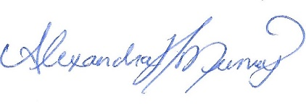 April 11, 2022
_______________________ ______________________
Executive Director Date

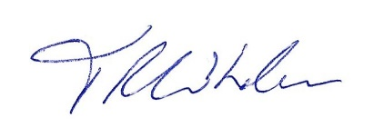 April 11, 2022
_______________________ ______________________
Board President Date

