BPS Procurement Directive 25 Mandatory Requirements | Section: Procurement  Number: 1.0
Approved: April 11, 2022 | Page: 1 of 3
Revised: | Scope: Overriding Policy Directions

POLICY:

The purpose of the Directive is to ensure that publicly funded goods and services, including construction, consulting services, and information technology are acquired by BPS organizations through a process that is open, fair, and transparent; to outline responsibilities of BPS organizations throughout each stage of the procurement process; and to ensure that procurement processes are managed consistently throughout the BPS.

PRINCIPLES:

Accountability
Community Living Oakville is accountable for the results of our procurement decisions and the appropriateness of the processes.

Transparency
Community Living Oakville is transparent to all stakeholders. Wherever possible, stakeholders must have equal access to information on procurement opportunities, processes and results.

Value for Money
Community Living Oakville must maximize the value they receive from the use of public funds. A value-for-money approach aims to deliver goods and services at the optimum total lifecycle costs.

Quality Service Delivery
Community Living Oakville will ensure that the front-line services they provide must deliver the right product, at the right time, in the right place.

Process Standardization
Community Living Oakville will ensure that standardized processes remove inefficiencies and create a level playing field.

25 Mandatory Requirements

1. Segregation of Duties
2. Approval Authority
3. Competitive Procurement Thresholds
4. Information Gathering
5. Supplier Pre-Qualification
6. Posting Competitive Procurement Documents
7. Timelines for Posting Competitive Procurements
8. Bid Receipt
9. Evaluation Criteria
10. Evaluation Process Disclosure
11. Evaluation Team
12. Evaluation Matrix
13. Winning Bid
14. Non-Discrimination
15. Executing the Contract
16. Establishing the Contract
17. Termination Clauses
18. Term of Agreement Modifications
19. Contract Award Notification
20. Supplier Debriefing
21. Non-Competitive Procurement
22. Contract Management
23. Procurement Records Retention
24. Conflict of Interest
25. Bid Dispute Resolution

Procurement Policies Abbreviations and Definitions
Abbreviation | Definition
BPS | Broader Public Sector
CLO | Community Living Oakville
FIPPA | Freedom of Information & Protection of Privacy Act
RFEI | Request for Expression of Interest
RFI | Request for Information
RFP | Request for Proposal
RFQ | Request for Quotation
RFSQ | Request for Supplier Qualifications
RFT | Request for Tender
VOR | Vendor of Record

Approved by:

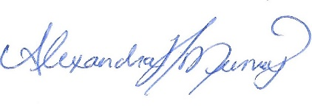 April 11, 2022
_______________________ ______________________
Executive Director Date

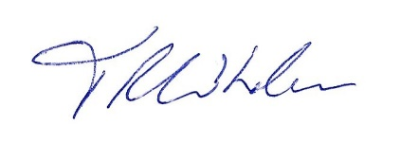 April 11, 2022
_______________________ ______________________
Board President Date

